erd c ware.bal
Santa Ana Winde (Bildergalerie)

Zum Vergrößern auf die jeweiligen Grafiken klicken!

.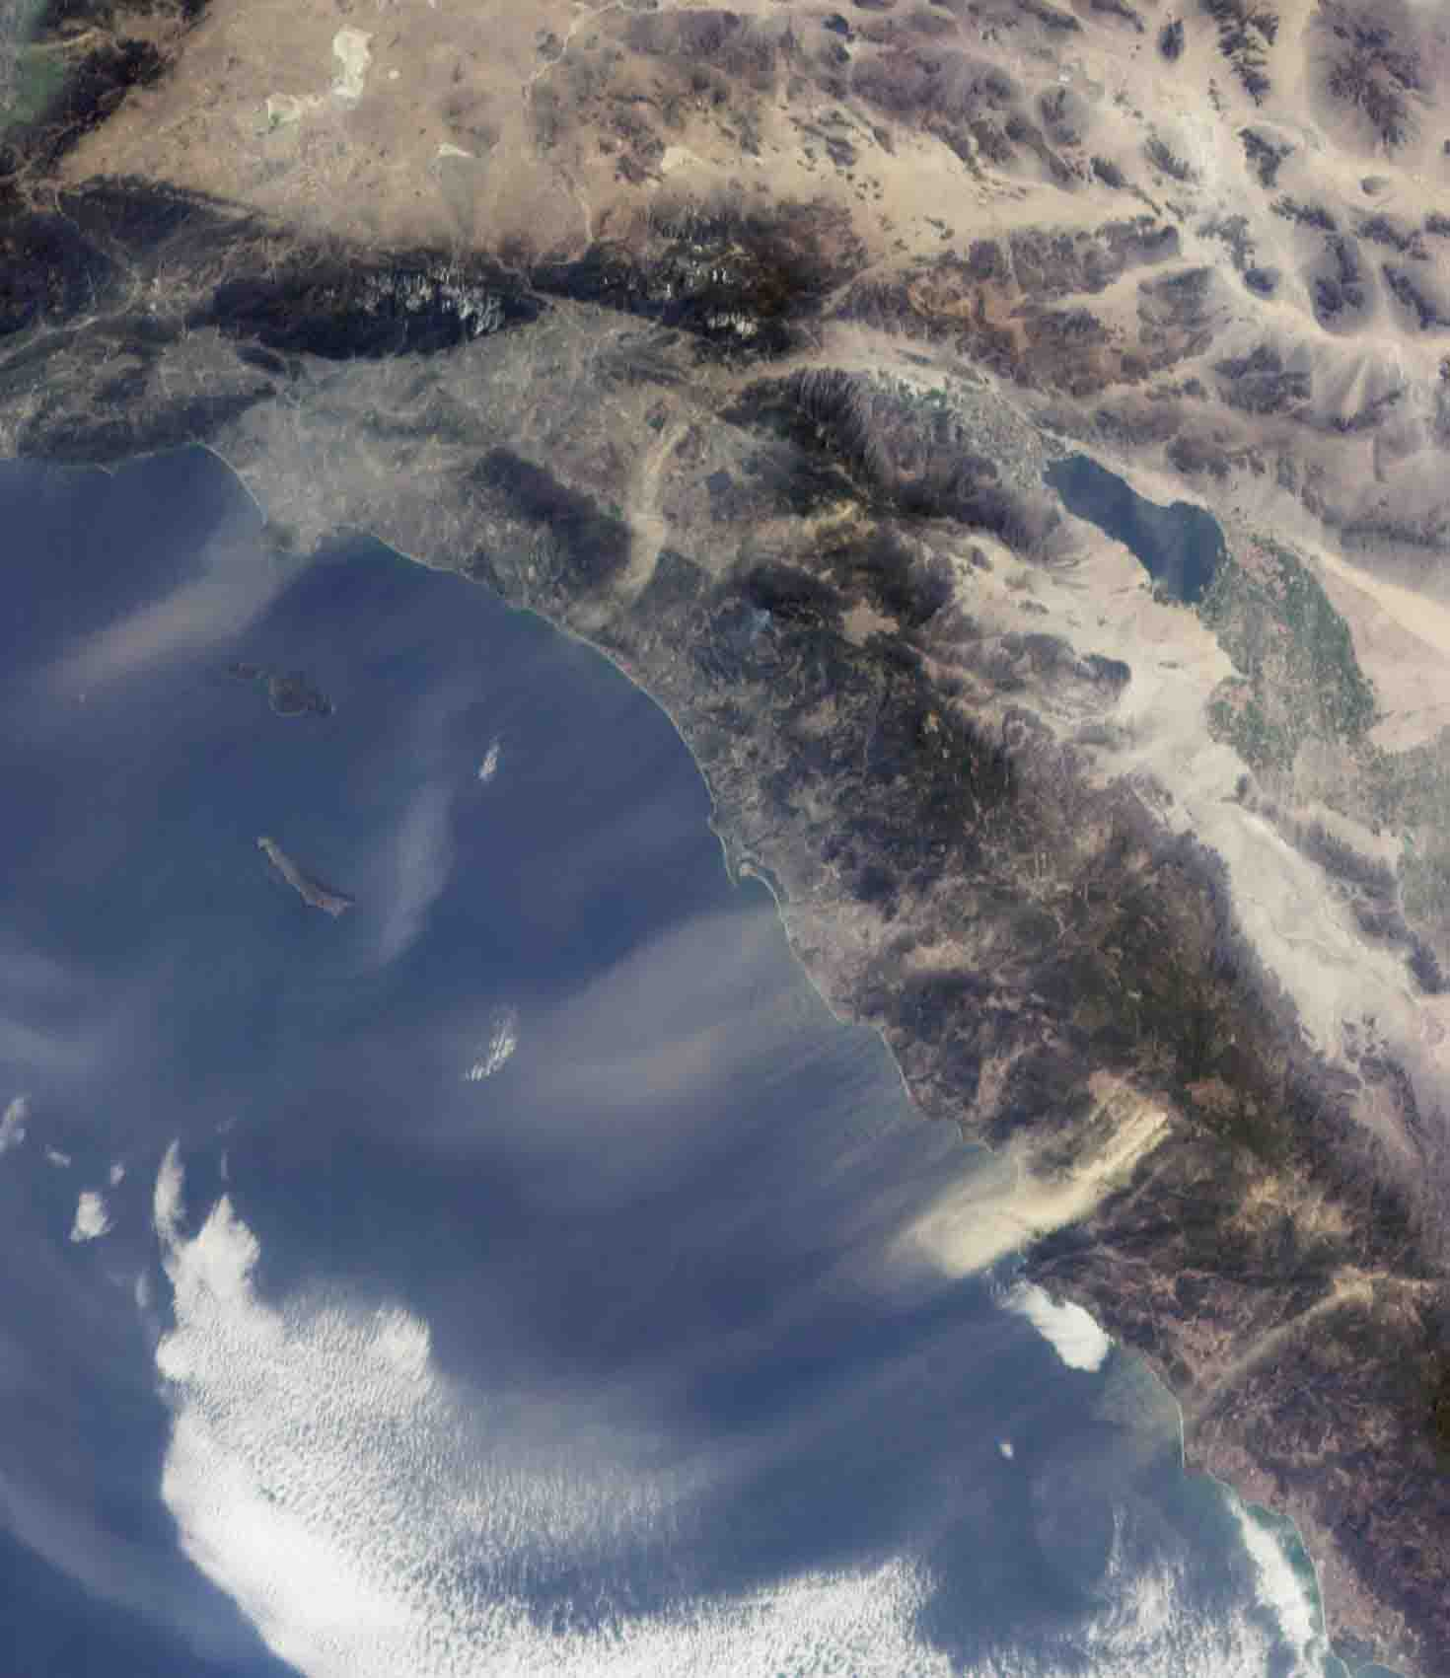  http://photojournal.jpl.nasa.gov/catalog/PIA03445  This view from the Multi-angle Imaging SpectroRadiometer shows the pattern of airborne dust stirred up by Santa Ana winds on February 9, 2002. The image is from MISR's 70-degree forward-viewing camera, and airborne particulates are especially visible due to the camera's oblique viewing angle. Southeast of the Los Angeles Basin, a swirl of dust, probably blown through the Banning Pass, curves toward the ocean near Dana Point. The largest dust cloud occurs near Ensenada, in Baja | 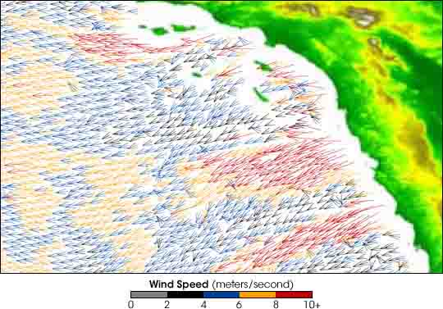  http://earthobservatory.nasa.gov/IOTD/view.php?id=4306  Southern California’s legendary Santa Ana winds wreak havoc every year, creating hot, dry conditions and fire hazards. This image was produced using data from the SeaWinds instrument aboard NASA’s Quick Scatterometer (QuikSCAT) spacecraft. The image shows strong winds blowing offshore all along the Southern California coast. The fastest winds are indicated in red, with orange, blue, black, and gray representing progressively slower wind speeds. Despite their ominous nickname—Devil Winds—the winds have some positive California, Mexico. Also visible in this image is a blue-gray smoke plume from a small fire located near the southern flank of Palomar Mountain in Southern California.  This image was acquired during Terra orbit 11423, and represents an area of about 410 kilometers x 511 kilometers.

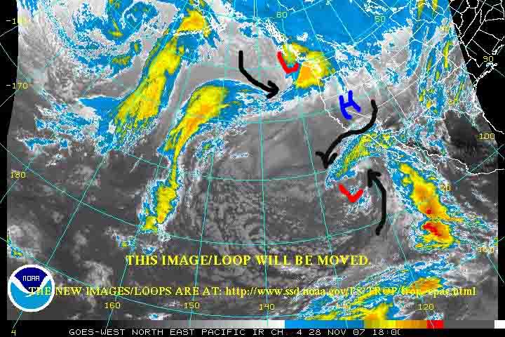  http://silt.ess.uci.edu/wp-content/uploads/2007/11/20.jpg | 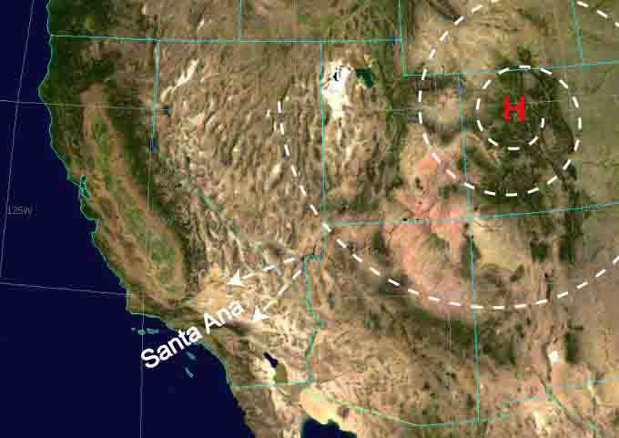  http://en.wikipedia.org/wiki/Image:Santa_ana_wind1.jpg
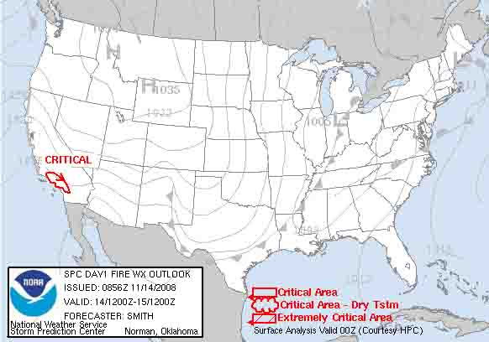  http://www.spc.noaa.gov/products/fire_wx/2008/081114.html  Fire Weather Outlook | 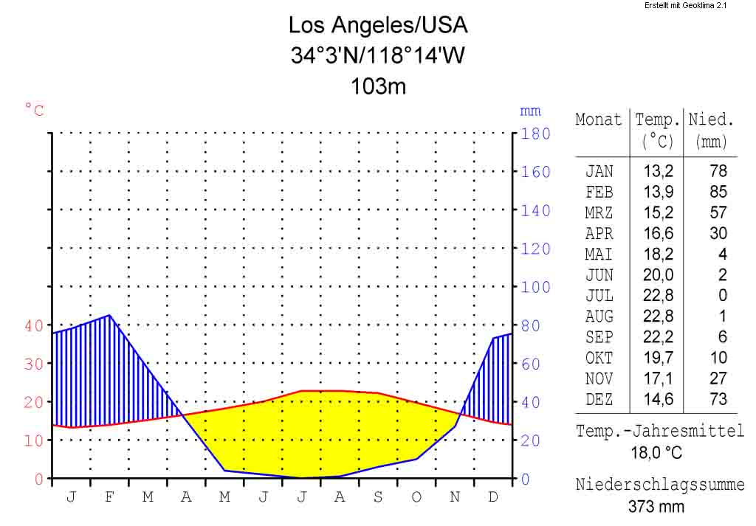  http://de.wikipedia.org/wiki/Bild:Klimadiagramm  -metrisch-deutsch-Los_Angeles-USA.png
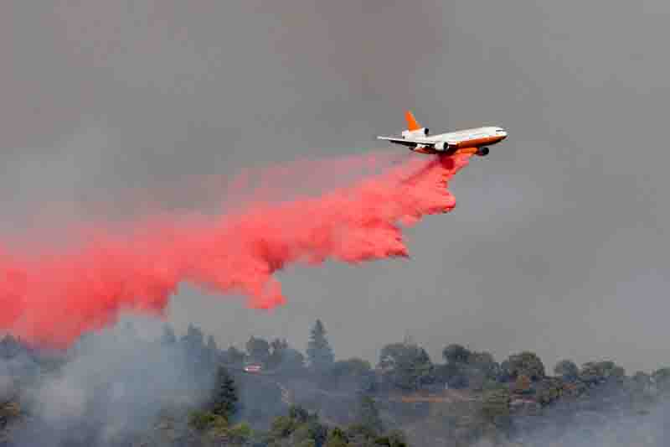  http://www.nasa.gov/centers/dryden/images/content/281281main_DC-10-tanker_screen.jpg | http://www.dfrc.nasa.gov/Gallery/Photo/Ikhana/Small/ED08-0151-02.jpg
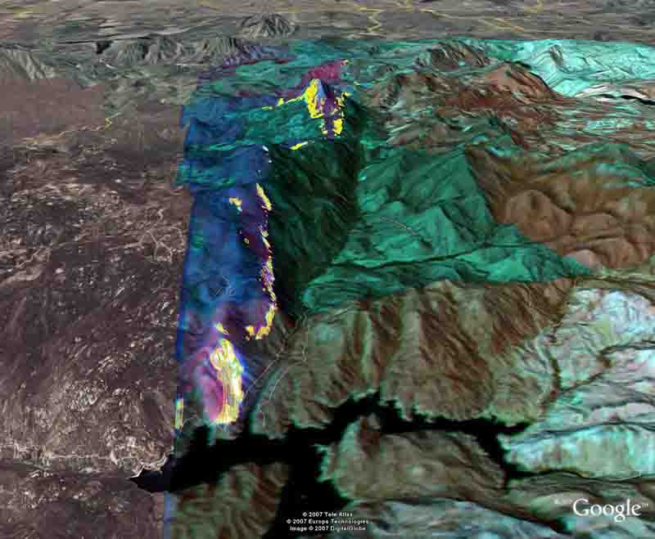  http://www.defenseindustrydaily.com/images/EVENT_NASA_MQ-9_Image_San_Diego_Fire_2007-10-24_lg.jpg | 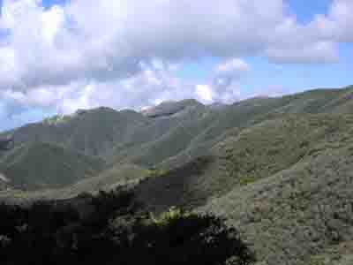  http://en.wikipedia.org/wiki/Image:Chaparral_California.jpg  Chaparral plant community; Santa Ynez Mountains, CA  Looking west from near Montecito Peak, approximate elevation 3500'; dense stands of ceanothus, chamise, scrub oak; this area has not had a wildfire since 1961.
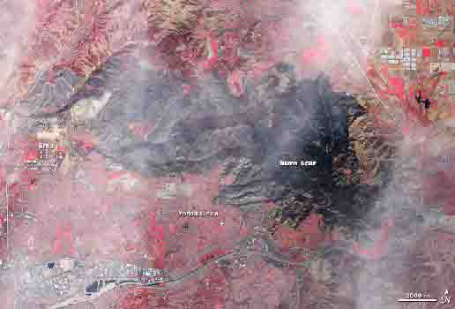  http://www.nasa.gov/mission_pages/fires/main/usa/califire_20081124.html  Several days after it started, the Freeway Fire left a sprawling burn scar on the California landscape. The Advanced Spaceborne Thermal Emission and Reflection Radiometer (ASTER) on NASA's Terra satellite captured this image on Nov. 22, 2008. In this false-color image, red indicates vegetation, tan indicates bare ground, gray-blue indicates buildings and paved surfaces, and dark blue indicates water. The Freeway Fire burn scar, stretching across the middle of the image, assumes a charcoal color. Along its southwestern margin, the burn scar intrudes into the curving suburban streets of Yorba Linda and Brea. | 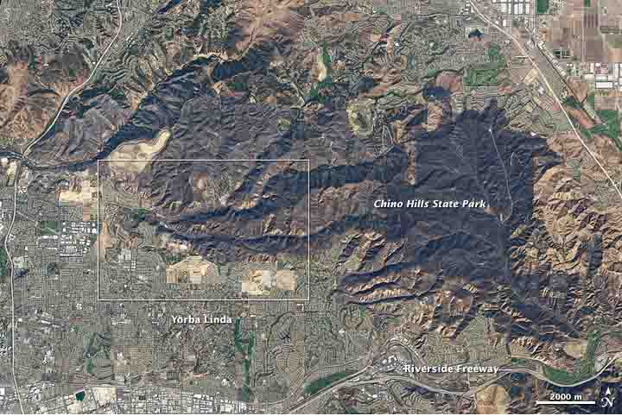  http://earthobservatory.nasa.gov/IOTD/view.php?id=36017  One hundred eighty-seven homes were destroyed by the Freeway Fire in Southern California in mid-November 2008. Driven by Santa Ana winds, the fire exploded out of the Chino Hills into communities at the foothills of the mountains. More than 30,000 acres were scorched by the fire.  This natural-color image of the burned area was captured by the Advanced Land Imager (ALI) on NASA’s Earth Observing-1 satellite on November 18, 2008. The top image shows the Chino Hills north of Riverside Freeway and west of Chino Valley Freeway, a mostly undeveloped area that encompasses Chino Hills State Park. Small cities and residential areas encircle the mountains. The burned area is charcoal, and it stretches across most of the Chino Hills. The lower image is a detailed view of the edge of the burned area in northwestern Yorba Linda. The fire crossed Telegraph Canyon and made forays southwestward into neighborhoods. One arm of the fire encircled Carbon Canyon Regional Park.  Southeast of the Riverside Freeway (shown in the large image), is a part of Chino Hills State Park called the Coal Canyon area. The area has a dull greenish-brown color that is typical for the dry woodland/chaparral ecosystems native to the area. (In this part of California, bright green vegetation is the product of irrigation, for example, golf courses and lawns.) The Coal Canyon area was added to China Hills State Park in 2000, and it was the only part of the ~14,000-acre park that was not burned, according to local news reports.

